|  |  |
| --- | --- |
|  | **DEPARTMENT OF COMPUTER SYSTEMS ENGINEERING**  **MEHRAN UNIVERSITY OF ENGINEERING & TECHNOLOGY, JAMSHORO**  **Database Management Systems (4th Semester) 18CS**  **Lab Experiment 12** |

|  |  |  |  |
| --- | --- | --- | --- |
| **Roll No:** |  | **Date of Conduct:** |  |
| **Submission Date:** |  | **Grade Obtained:** |  |

|  |  |  |  |
| --- | --- | --- | --- |
| **Problem Recognition (0.3)** | **Completeness & accuracy (0.4)** | **Timeliness (0.3)** | **Score (1.0)** |
|  |  |  |  |

**Objective**: **To explore Exception Handling in PL/SQL.**

**Tools: MySql, Oracle.**

**Introduction:**

An exception occurs when the PL/SQL engine encounters an instruction which it cannot execute due to an error that occurs at run-time. These errors will not be captured at the time of compilation and hence these needed to handle only at the run-time.

For example: if PL/SQL engine receives an instruction to divide any number by '0', then the PL/SQL engine will throw it as an exception. The exception is only raised at the run-time by the PL/SQL engine.

Exceptions will stop the program from executing further, so to avoid such condition, they need to be captured and handled separately. This process is called as Exception-Handling, in which the programmer handles the exception that can occur at the run time.

## Exception-Handling Syntax:

## Exceptions are handled at the block, level, i.e., once if any exception occurs in any block then the control will come out of execution part of that block. The exception will then be handled at the exception handling part of that block.

## 

## Types of Exception:

1. Predefined Exceptions
2. User-defined Exception

## Predefined Exceptions: Oracle has predefined some common exception. These exceptions have a unique exception name and error number. These exceptions are already defined in the 'STANDARD' package in Oracle. In code, we can directly use these predefined exception name to handle them.

## User-defined Exception: In Oracle, other than the above-predefined exceptions, the programmer can create their own exception and handle them. They can be created at a subprogram level in the declaration part. These exceptions are visible only in that subprogram. The exception that is defined in the package specification is public exception, and it is visible wherever the package is accessible.

DECLARE

<exception_name> EXCEPTION;

BEGIN

<Execution block>

EXCEPTION

WHEN <exception_name> THEN

<Handler>

END;

* In the above syntax, the variable 'exception_name' is defined as 'EXCEPTION' type.
* This can be used as in a similar way as a predefined exception.

**Lab Task**

**1. Write a PL/SQL block that updates description of a product and raises a user-defined exception when that product is not found.**

**Task:**

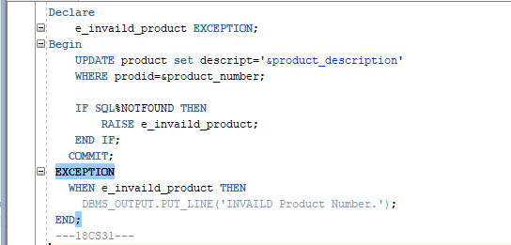

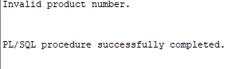**Output:**

**2. Write a simple PL/SQL code block, to demonstrate the use of Named Exception Handler for division by zero error.**

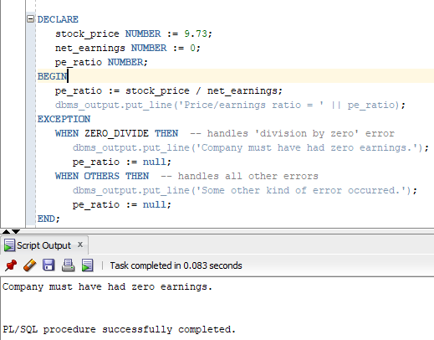**Task:**

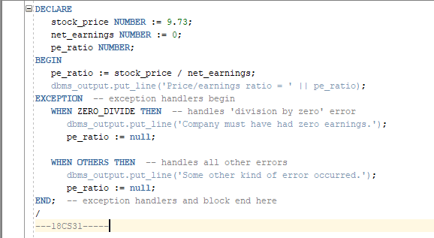

**3.** **Write a PL/SQL block for displaying information of a customer ID, when the user enters an invalid ID, raise the exception invalid_id.**

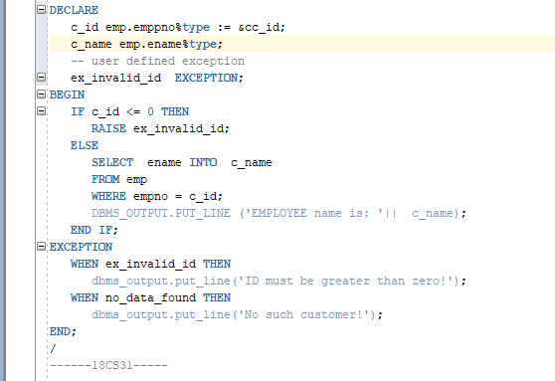**Task:**

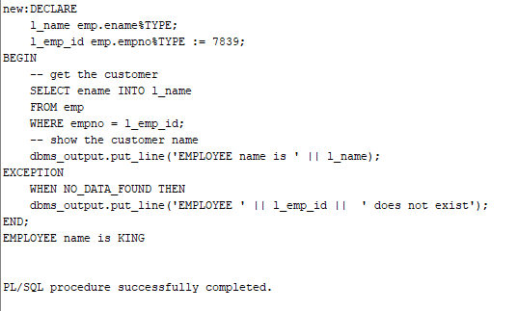**Output:**